Basha Bands ½ Gallon Water Jug Order Form
(Please Print)
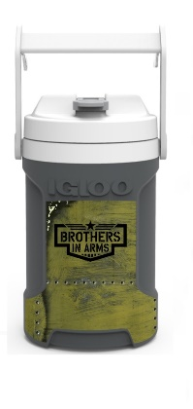
Student Name: ___________________________________________________________
Student Instrument / Section: _______________________________________________

Parent Name: ____________________________________________________________
Parent E-Mail: ____________________________________________________________
Parent Phone Number: _____________________________________________________
Booster Use Circle One
Paid Via: Cash Check Credit Card

